Final Project Description

Including:

* Outdoor 25%
* Indoor 25%
* Multiple Cameras(mirror) 10%
* Texture on Indoor Section 5% with Normal Map 5%
* Particle Effects 10%
* NavMesh Agents 5%
* Direct Light Source Indoor 5%
* Physics Control 5%
* Simple Animation(sun) 5%

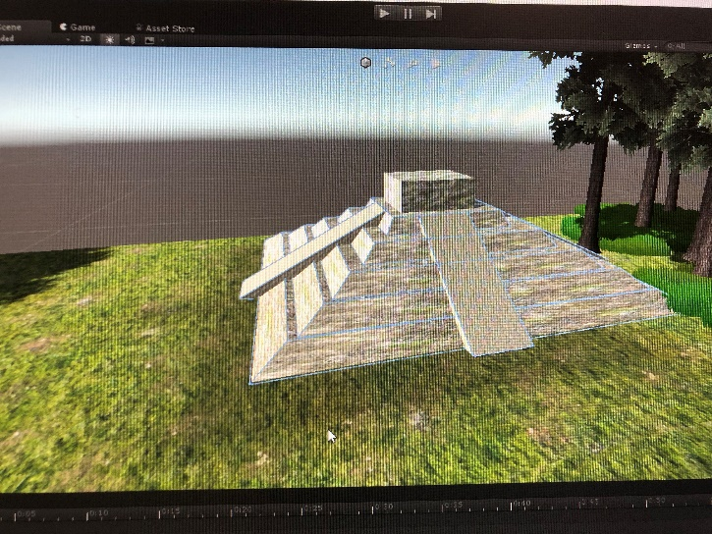Description:

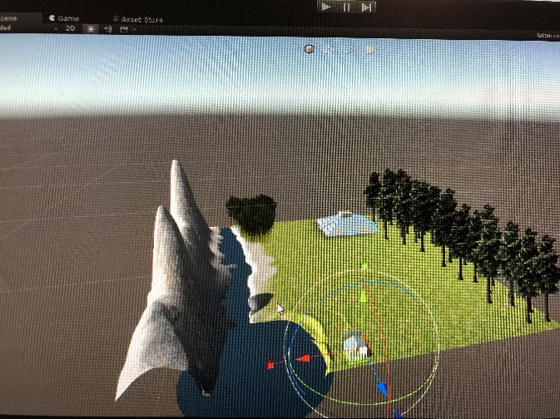I built a Mayan pyramid successfully, but it is not exactly look like the real one. I like player could still indentify that is a Mayan pyramid.

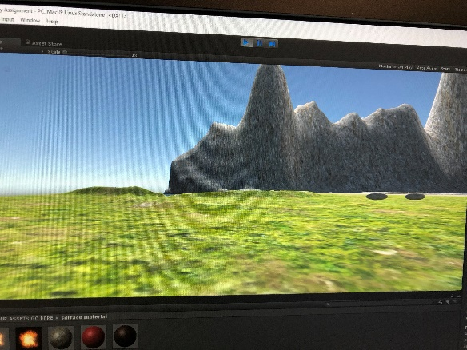At the Game plan I mention that I will created the terrain look like a forest in Mesico, the problem is when I start to create it, I understood that the file will be too big to play if I add a lot of tree and grass.

I said that I will put a mount of invisable door and items to interact with, I put two door in the game successfully. But still cannot understand how to use the trigger, that is why I didn’t put any items in the game.

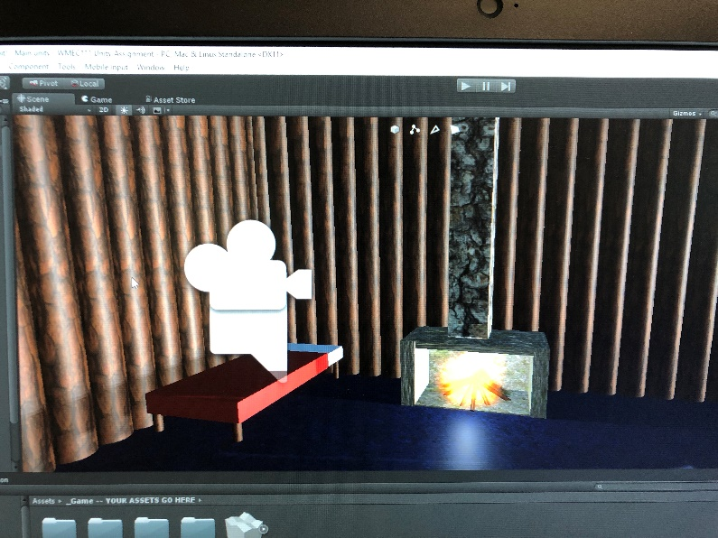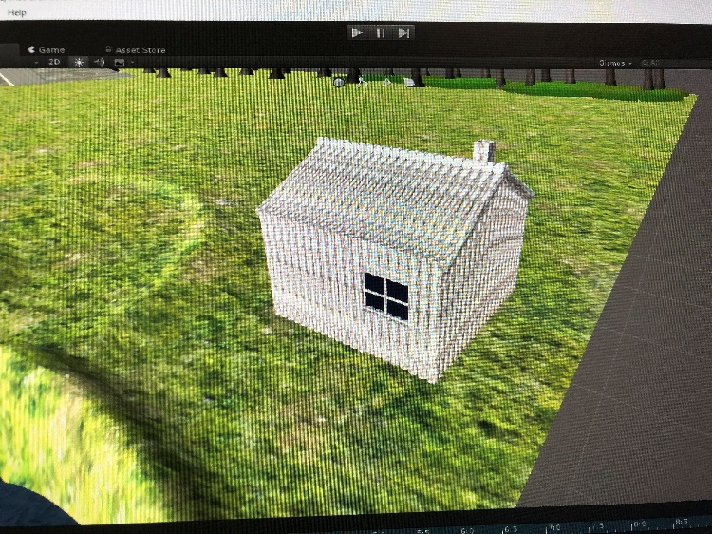I use the wood material I create on my house, I think I spent too much time to make my indoor program look pretty, I should pay more time on my invisible door and how the trigger work, which is my main program in the game.

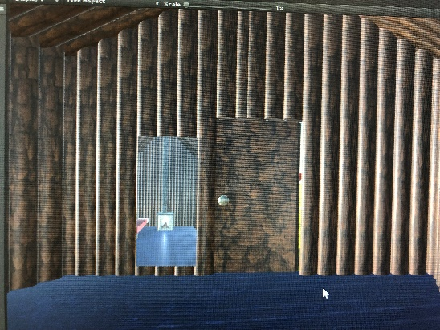I put a fireplace, bed and a mirror to make my indoor section looks better.

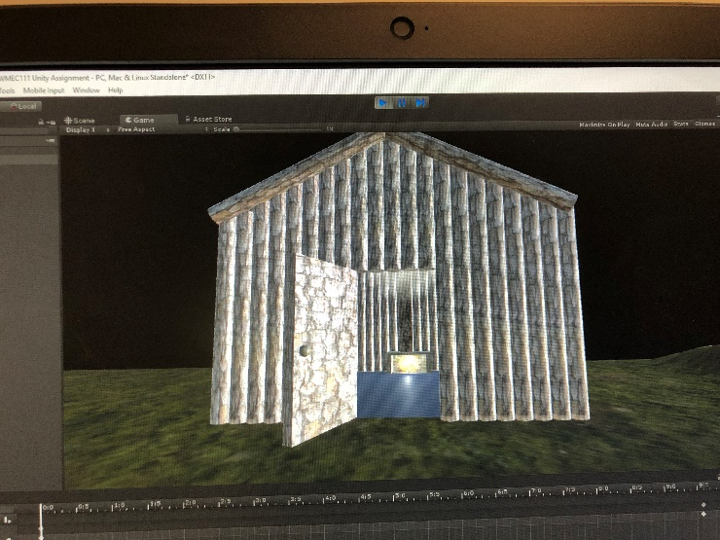

Despite I didn’t put everything I mention in the game plan, I think I still create a game allow to interact with.